|  |  |
| --- | --- |
| **Name** | Ian Towey |
| **Student #** | 04128591 |
| **Course** | STAT40840: Data Prog with SAS |
| **Assignment #** | 2 |
| **Date** | 5th May 2016 |

1. **Dataset Summary**

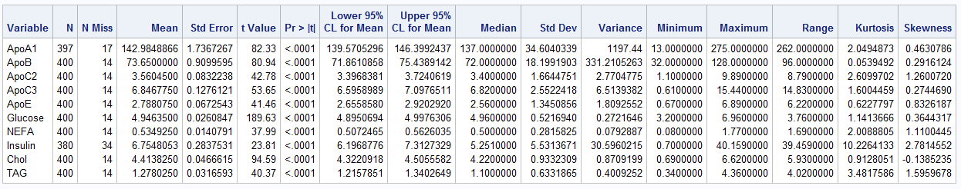

The table above presents summary statistics for the blood biochemcial component measured in the experiment. A few interesting points from this are

* 1. The standard deviation of the *Insulin* is very high
  2. Insulin is right skewed with a few extreme value 6 standard deviations from the mean
  3. 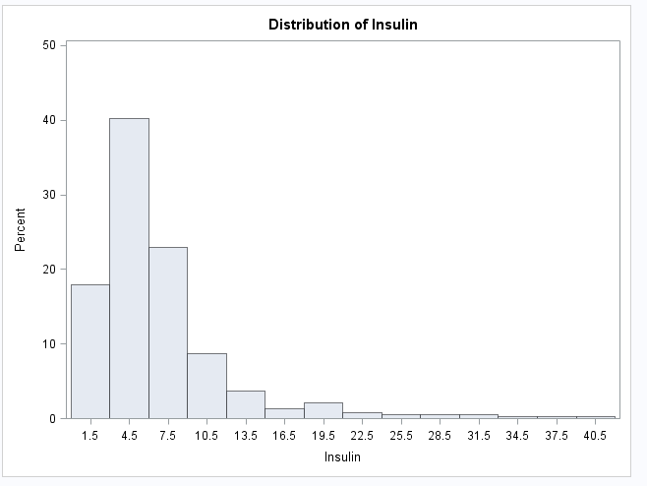
  4. Cholesterol is the only vaiable that is left skewed.

1. **Correlation Analysis**
   1. 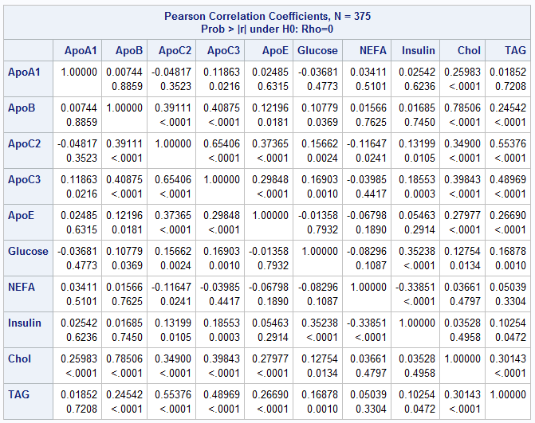Apolipoprotein B and Cholesterol has a high positive correlation at 0.78506

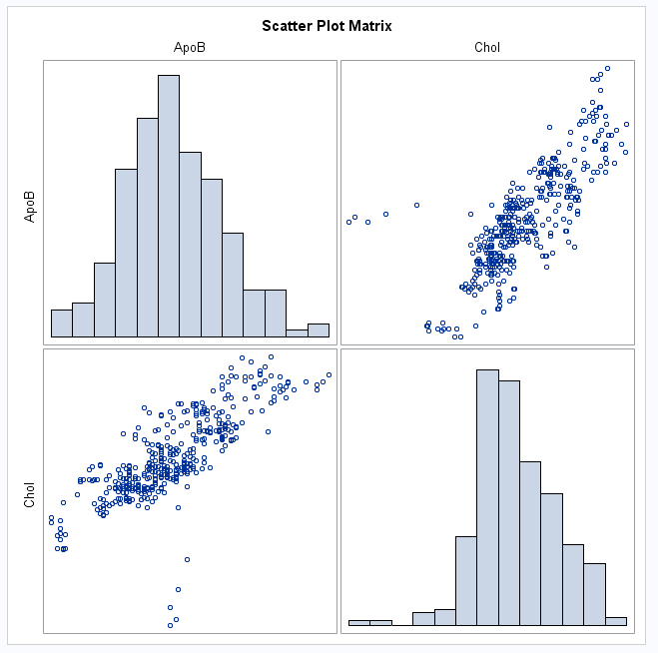

Apolipoprotein C2 and Apolipoprotein C3 has a high positive correlation at 0.65406

* 1. Apolipoprotein A1 and Apolipoprotein B have least correlation

1. **Partial Correlation Analysis**
   1. 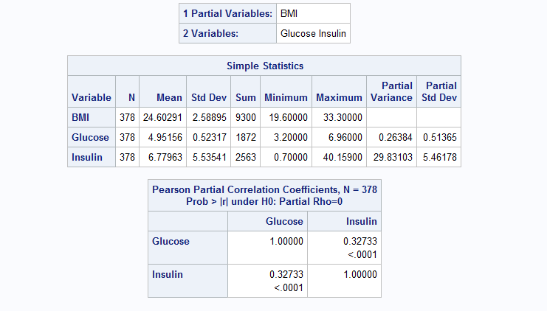The partial correlation between the variables Glucose and Insulin is 0.32733, which is a little less than the unpartialled correlation, 0.35238. The p-value for the partial correlation is less than 0.0001.
2. **Linear Model**

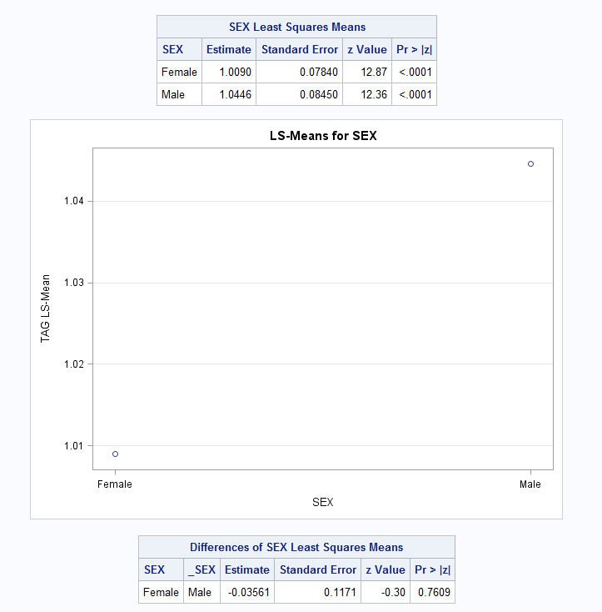

* 1. The estimate for the TAG response variable are not different for males and females

1. **Log normal Model**
   1. 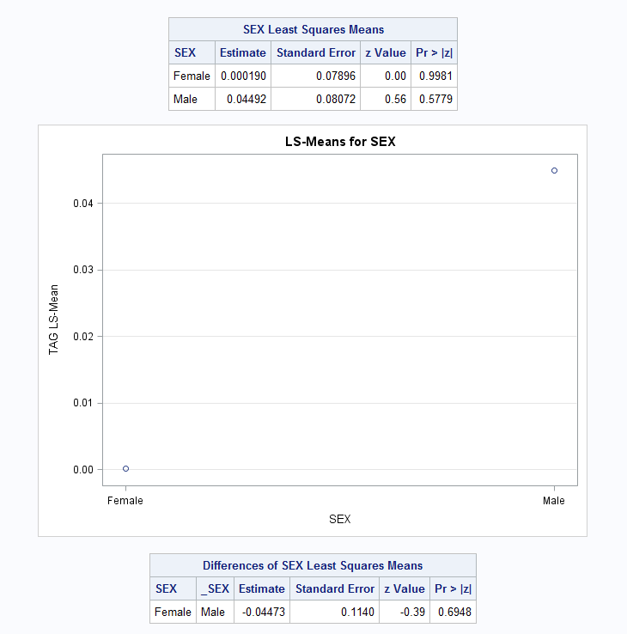The estimate for the TAG response variable are not different for males and females for a log normal model
2. **Mixed linear model**

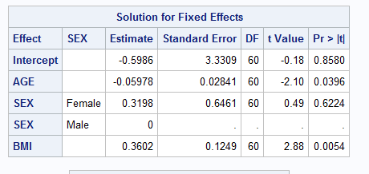

1. ar(1) model

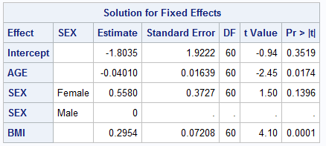

1. arh(1) model

The fit of arh(1) model has a smaller variance than that of the ar(1) model